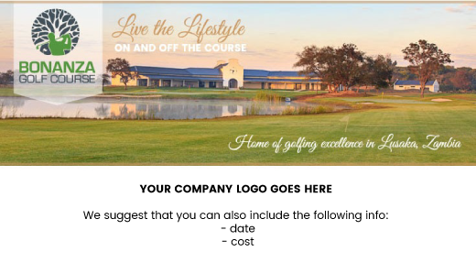

**INVITATION**

**You are invited to participate in the *“your golf day name”* Golf day on *“date here”***

**VENUE:** Bonanza Golf Course

**FORMAT:** “your competition format goes here”

**COST :** “cost per fourball or player goes here”

**PLAY FOR A PURPOSE:** Details of your golf day and the reason you are hosting it can go here. If you are entertaining clients this may be a thank you message for their support. If you are a charity you might want to include some pictures and pull on some heartstrings.

**SPONSORSHIP OPPORTUNITES:** All 18 holes as well as the practise area will be available for sponsorship / branding. Your presence at the hole will be a great opportunity to introduce your company or products to the business people attending.

**BOOKINGS & QUERIES:** “Golf day manager name / cell number / email address goes here”

Closing date for bookings is “date goes here”

**BOOKING FORM** Please complete the form below to book your 4-ball, email to “organizer email goes here”.

|  |  |  |  |
| --- | --- | --- | --- |
| **Contact person:** |  | | |
| **Telephone:** |  | | |
| **Email:** |  | | |
| **Company** |  | | |
| **VAT number (if applicable):** |  | | |
| **Address** |  | | |
| **Invoice required** | Yes / No | **Would you like to pay by credit card?** | Yes / No |

|  |  |
| --- | --- |
| **Name of Player** | **Handicap** |
| **1.** |  |
| **2.** |  |
| **3.** |  |
| **4.** |  |

**Sponsorship:** Sponsors will be allowed to display signage at their chosen hole (and serve refreshments at request). They will also be allowed to put up one banner at the prize giving dinner as well as at the registration area. Sponsors logo will appear on the dinner programme. *(prices below are common examples, add your own)*

|  |  |  |  |
| --- | --- | --- | --- |
| **Description** | **Cost** | **Qty** | **Total** |
| **4-ball only** | K3500 |  |  |
| **Sponsor a hole:**  Premium (holes 1,9,10 &18)  Standard (remaining holes)  Practise green  Preferred hole? | K3500  K1500  K500  *Please specify:* |  |  |
| Extra guests at dinner | K200 |  |  |
| *Please contact us should you have any questions regarding sponsorship* | | **TOTAL** |  |

|  |  |
| --- | --- |
| Would you be prepared to sponsor prizes for the golf day? | Please specify: |
| Would you be prepared to sponsor prizes for the raffle? | Please specify: |
| Would you like to supply and product or gift for the goody bags? | Please specify: |

**YOUR COMPANY GOLF DAY NAME GOES HERE**

**YOUR COMPANY LOGO**

**GOES HERE**